**Data**

The original data had 330 entries for resorts and 27 columns. Big Mountain resort is one of these entries. There are two variables for ticket price. One is AdultWeekday and the second is AdultWeekend. In the original data 15-16% of the data in these columns are missing. Just over 82% of resorts have no missing ticket price, 3% are missing one value, and 14% are missing both.After cleaning the data there are 277 rows and 25 columns left.

**Exploratory Data Analysis**

The features that were compared between each state are: Total population, Resorts per state, Total skiable area, Total night skiing and Total days open. I can offer some justification with treating all states equally, there isn't any clear grouping at this point. However some features that stand out which may indicate a price increase are resorts per 100k capita and resorts per 100k square miles. After looking at the feature correlation heatmap in figure 1 there are some features that are strongly correlated to the adult weekend price ticket, these include:fastQuads, Runs,  Snow Making area, resort_night_skiing_state_ratio, total_chairs and vertical drop.

**Figure 1. Feature correlation heatmap**

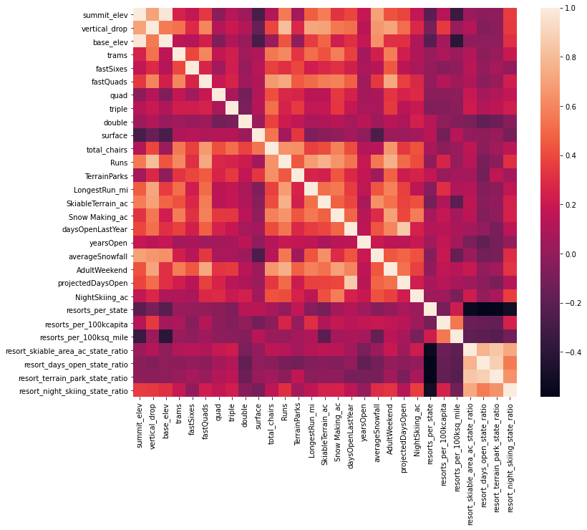

**Figure 2. Best random forest regressor feature importance**

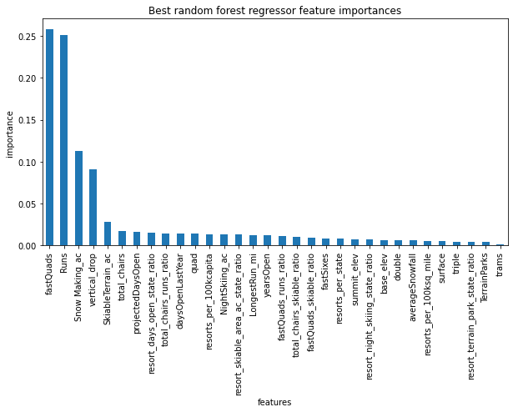

After running a random forest model, the features that came up as important in the modelling included: Vertical_drop, Snow Making_ac, total_chairs, fastQuads, Runs, LongestRun_mi, trams and SkiableTerrain_ac. This can be seen in figure 2.

**Recommendations**

Big Mountain currently charges $81.00. The modelled price is $95.87. The mean absolute error is $10.39 so this still gives room for a price increase. Adding an additional run, chair lift, and increasing the vertical drop by 150m will support a price increase of $8.61. Over the season this could increase the sales by $15,065,471. The operating costs for adding a new lift for the season is $1,540,000. I would suggest to business leadership that the sales increase from adding a new lift significantly outweigh the operating costs. At this point I would not recommend cutting any runs as this will decrease the price of each ticket and revenue.

**Figure 3. Ticket price prediction from closing runs.**

